

PROJECT SUBMISSION FOR INT – 219

NAME :- AMARTYA DIXIT

REGISTRATION NUMBER :- 11802442

ROLL NUMBER - 38

SECTION – K18VQ

SUBMITTED TO – TWINKLE CHAWLA MA’AM

TABLE OF CONTENTS

1. Introduction 1
2. Description About the Website 2

Screen-Shots(Code)

1. Screenshot of Code part - 1 3
2. Screenshot of Code part - 2 4
3. Screenshot of Code part - 3 5
4. Screenshot of Code part - 4 6
5. Screenshot of Code part - 5 7
6. Screenshot of Code part ­– 6 8

Screen-Shots(Output)

1. Screenshot of Output part – 1 9
2. Screenshot of Output part – 2 10
3. Screenshot of Output part – 3 11
4. Screenshot of Output part – 4 12
5. Screenshot of Output part – 5 13
6. Screenshot of Output part – 6 14

INTRODUCTION

Olympics are one of the most famed events around the globe. The modern Olympics were first held in 1896 at the beautiful city of Athens. Olympics were created by Pierre de Coubertin and were called as “Games of the Olympiad”.

The Olympics are held in every in every 4 years(excluding 1940 Olympics and 1944 Olympics) , the official logo of the games consists of 5 inter-circled rings of blue, green, yellow , black and red which represents the five continents of the world , united by Olympism.

The Motto of the Olympics are – “Citius , Altius , Fortius” which means faster , stronger , higher. The International Olympic Council(IOC) is the governing body of the Olympics which decides and regulates the conduct of the Olympics. The head-quarters of IOC are located in Lausanne , Switzerland.

The Olympics are one of the most seen events in the history of the mankind with an average of over 1 billion viewers in every Olympic.

DESCRIPTION ABOUT THE WEBSITE

This website is a student developed for Rio Olympic 2016. This Website consists of a navigation panel, Olympic logo, 6 webpages and a footer section. Navigation panel consists of ‘Home’ , ‘Sports’ , ‘Venues’ , ‘Medal Tally’ , ‘Book a Venue’ and ‘About’. The footer section consists of the developer information and a button which will redirect the user to mail section for putting any queries or suggestions.

First Page is the “Home” page of the website which consists of time line for the Olympics , insight stories as well as gallery for the Olympics. At the top the background video is encoded in auto-play manner. Just below it , is the timeline for the Olympics , below it are the insight stories and at the last we have a gallery section.

Second Page is the “Sports” page which consists of a 3 columned table where name of all the sports are placed and as soon as you click on any of the sports , it will redirect you to the page for the sports.

Third Page is the “Venues” Page which consists of all the venues for Rio Olympics entitled into a tabular form. Just below the table you will find the photographs of some the important venues for the Olympics which are encoded in a zoom-hover format.

Fourth

OUTPUTS

Index(Home) Page –

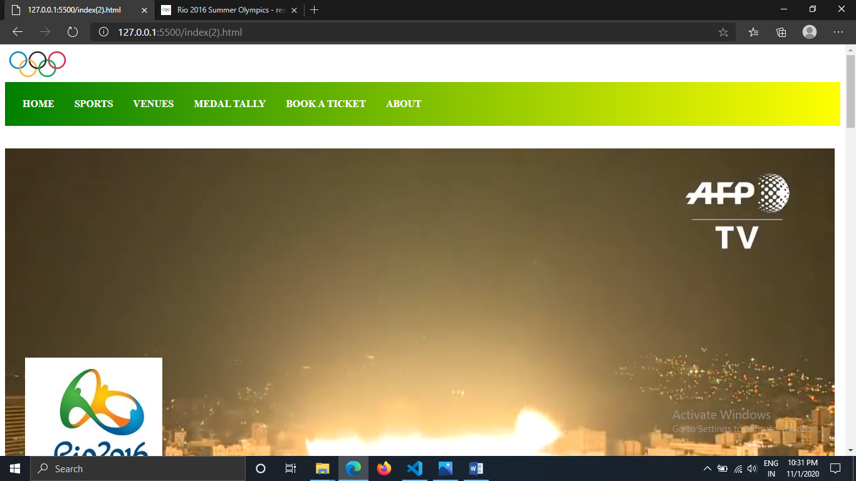

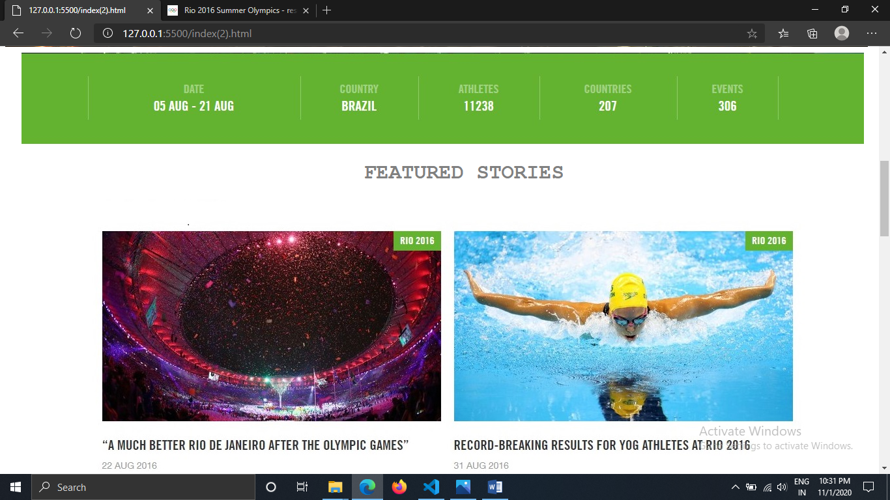

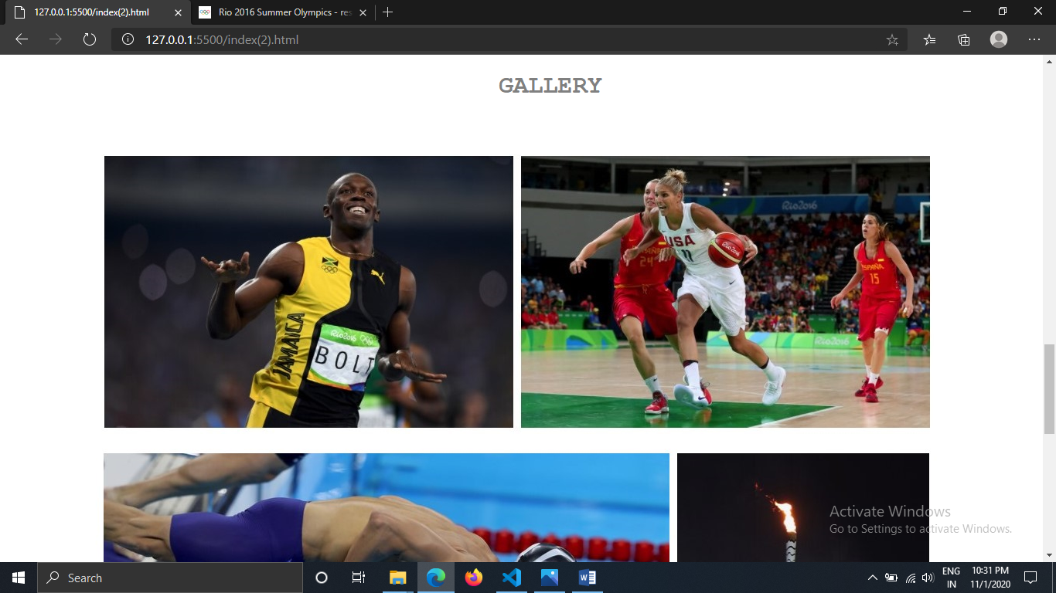

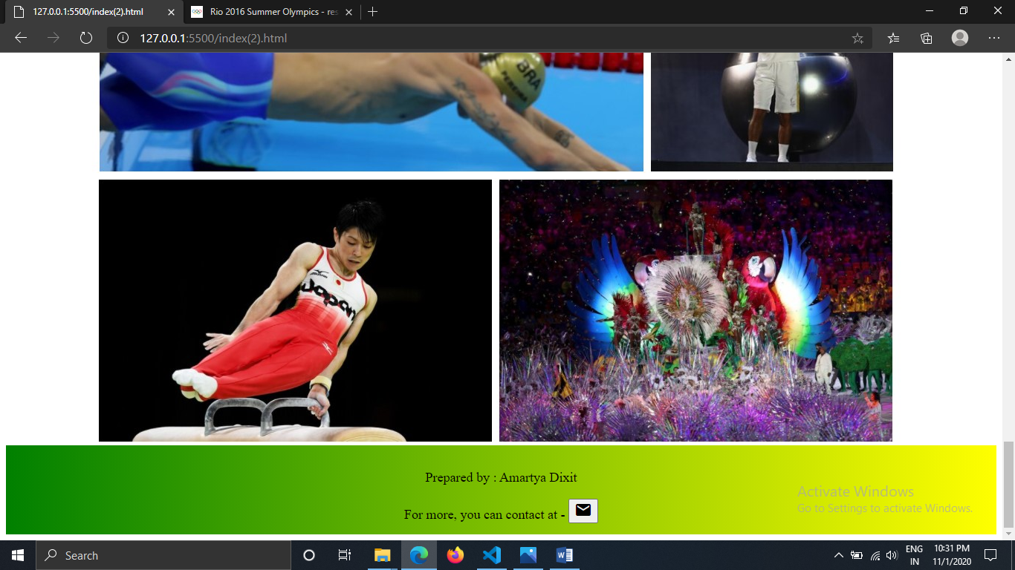

OUTPUT

Sports Page –

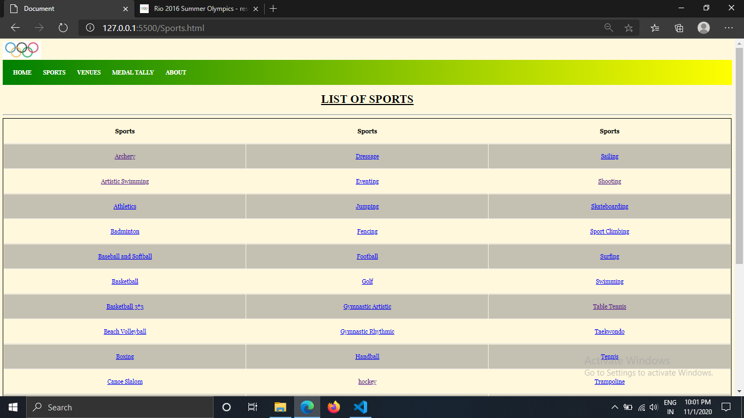

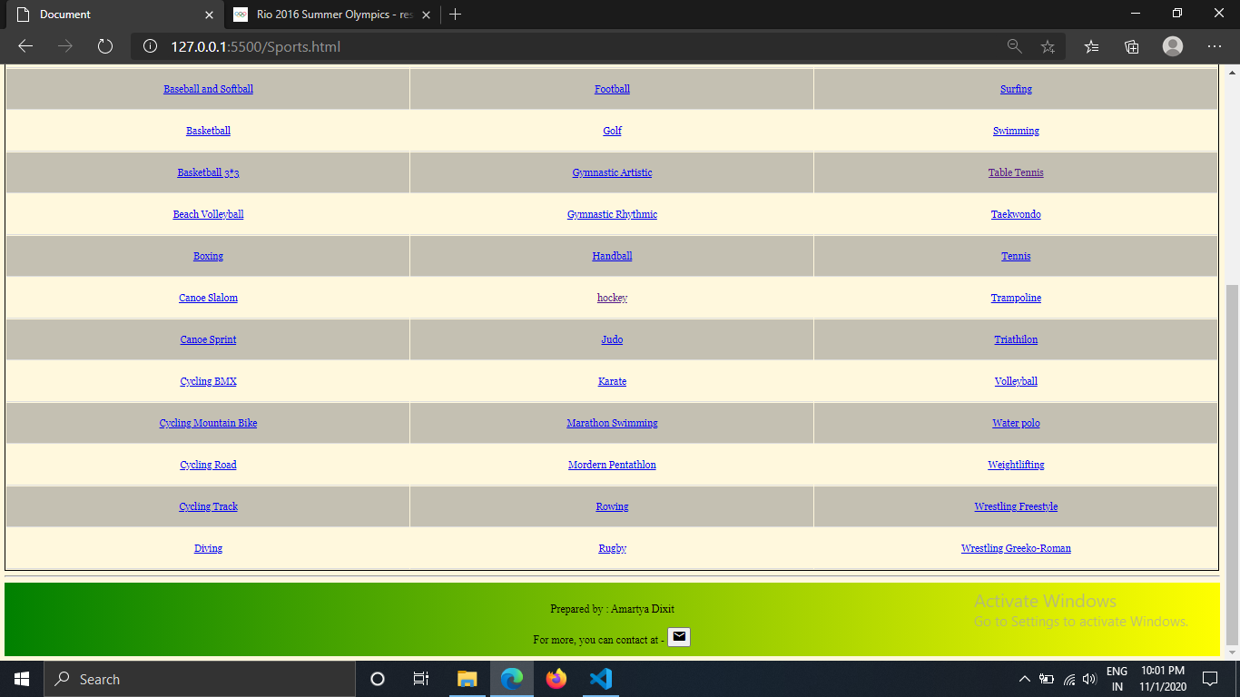

OUTPUTS

Venues(3rd) Page –

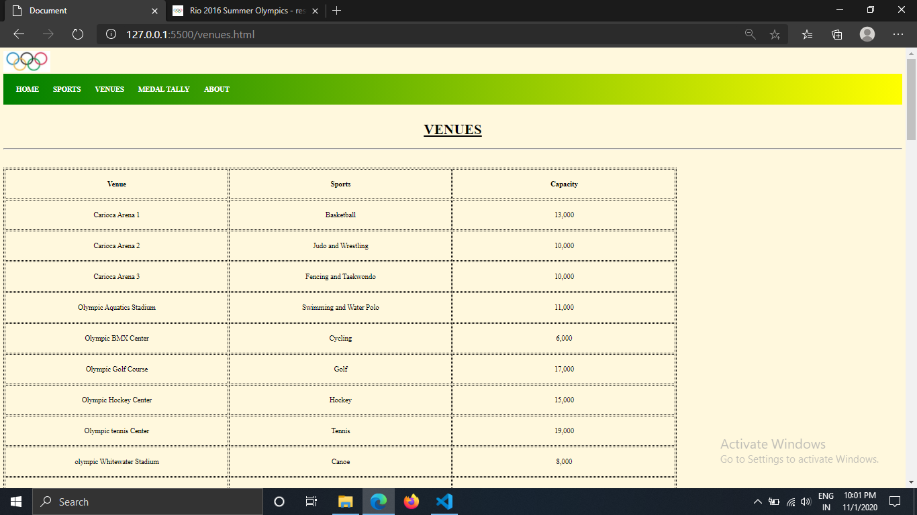

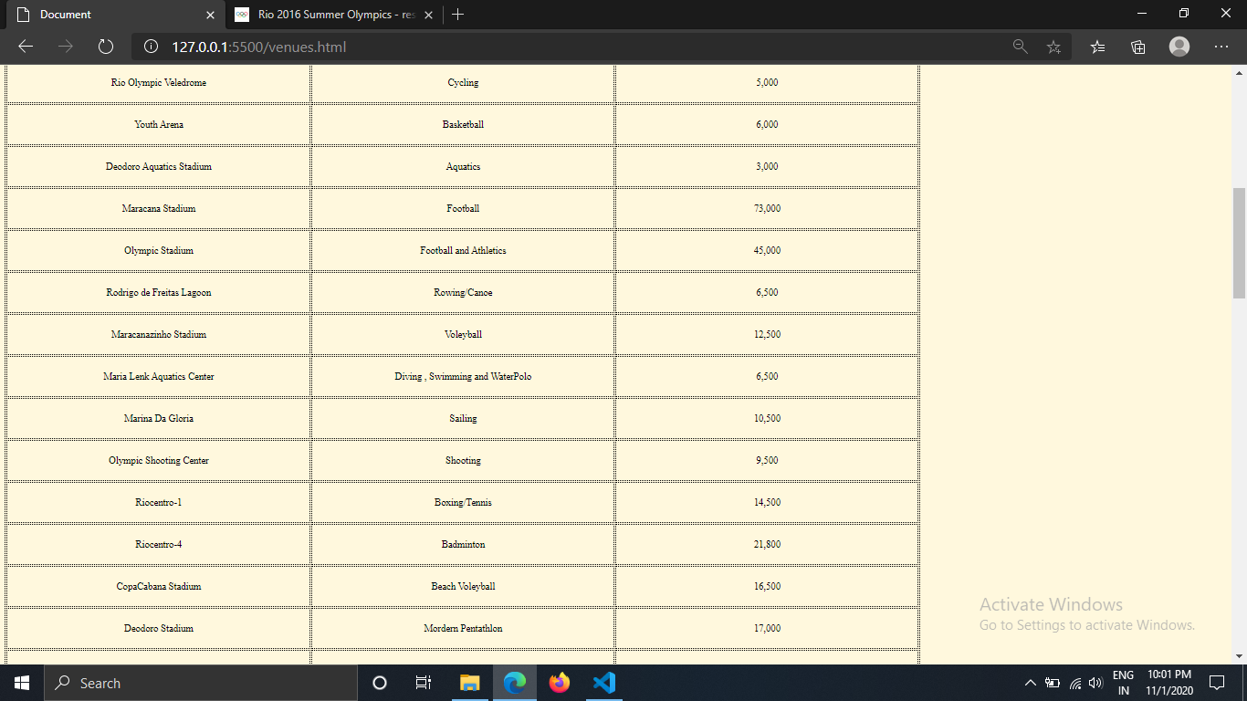

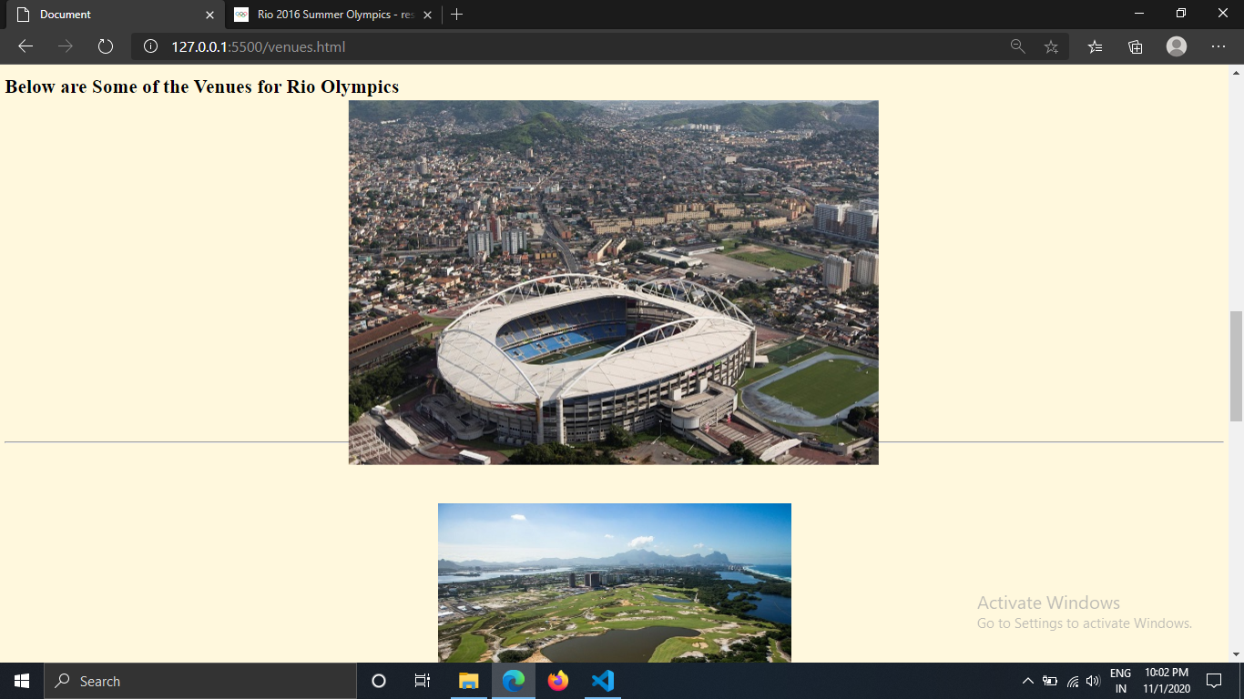

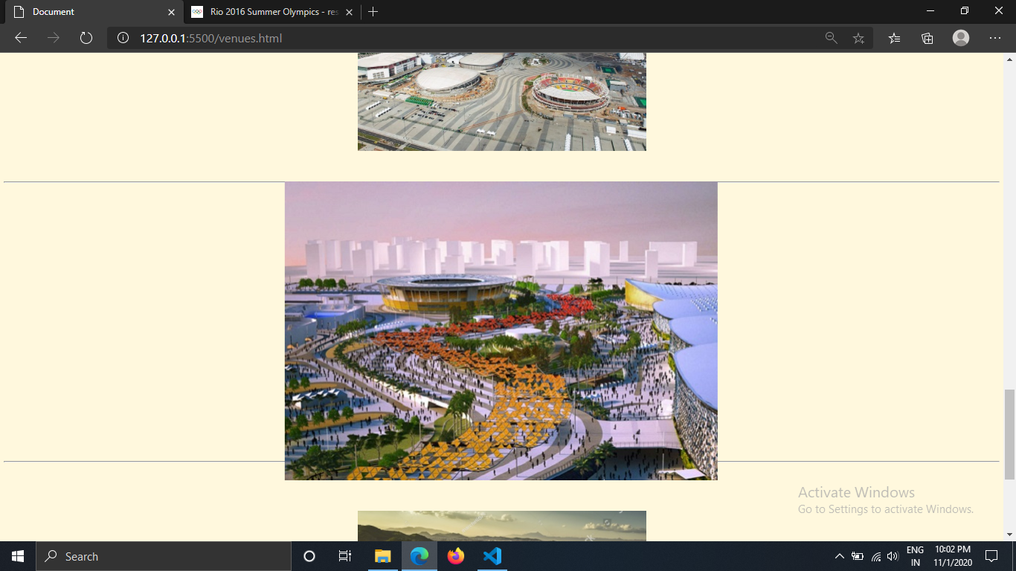

OUTPUTS

Medal Tally(4th page) –

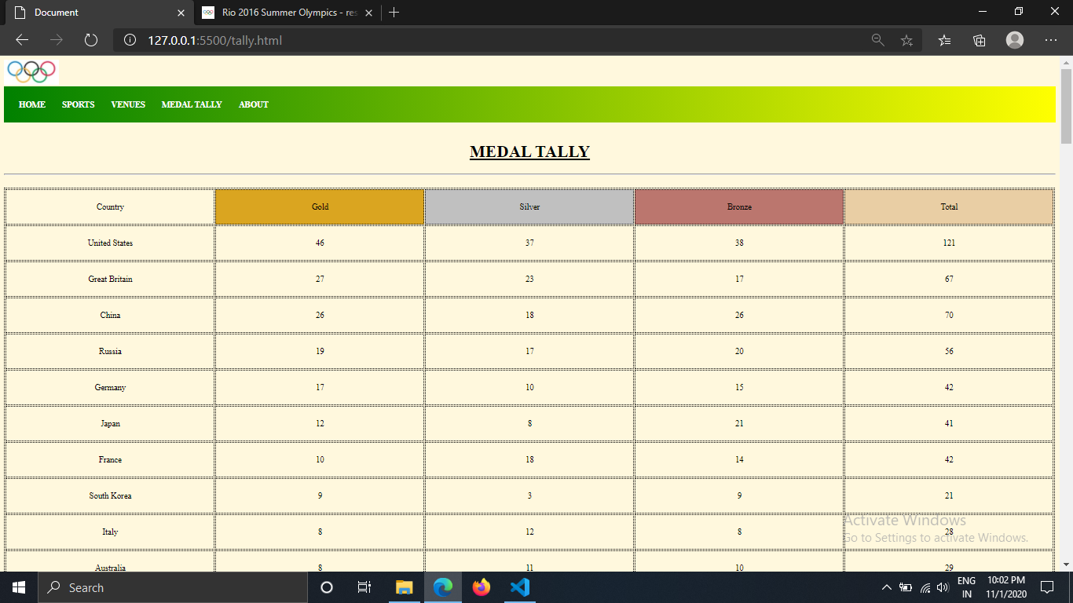

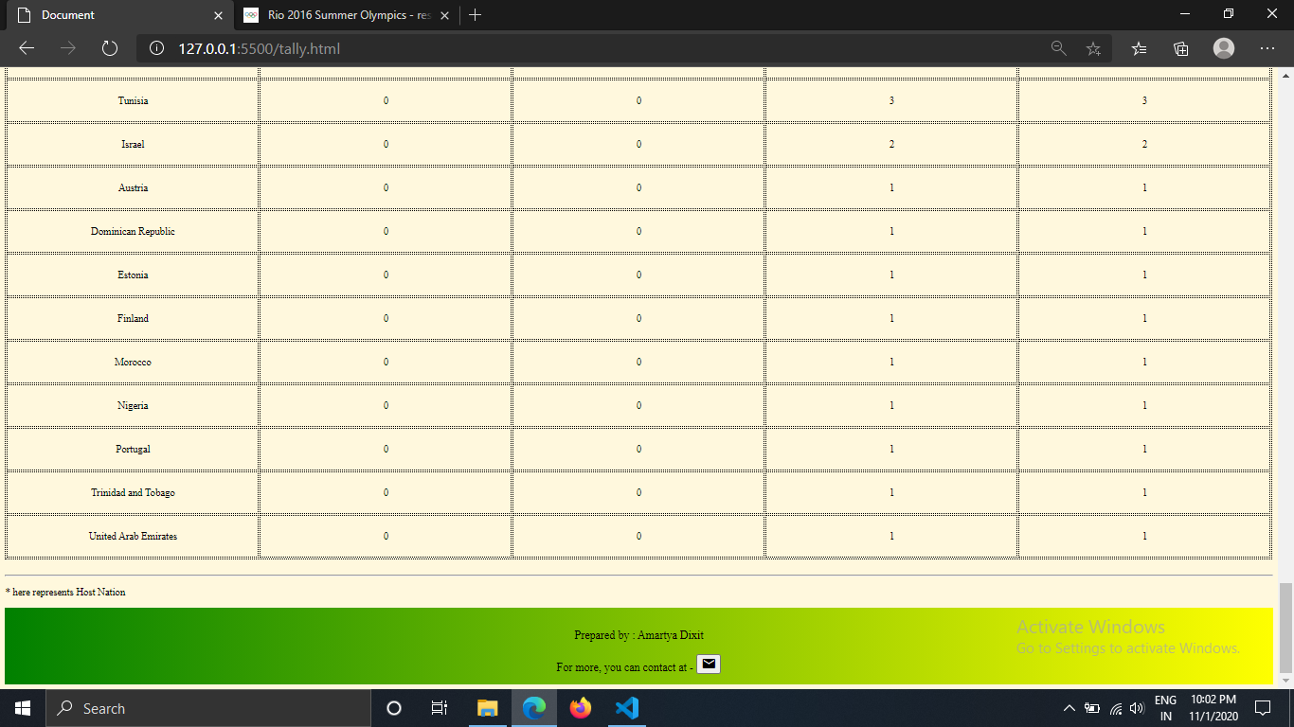

OUTPUTS

About(5th) Page –

